Chemistry 20

Lesson 28 – Acid/Base Stoichiometry

# Acid base stoichiometry

As we saw in Lesson 25, acids and bases neutralize each other.

HCl (aq) + NaOH(aq) **→** NaCl (aq) + HOH(l)

However, we have a problem − how do we know when the reaction is complete? In our previous work we saw an observable event that indicated that the reaction was complete. When we decomposed malachite the colour changed from a grey-green to a dark black. The reaction between colourless calcium chloride and sodium carbonate solutions resulted in a white precipitate. For an acid/base neutralisation, there is no readily observable change.

# Titration

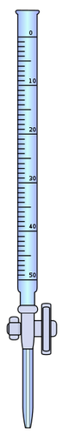

buret tube

stop cock

tip

A **titration** is an important laboratory technique to determine the unknown concentration of a solution. For a complete description of the technique and the terminology involved, refer to pages 328 to 330 and page 804 in the text. Titration involves the use of a burette (or buret) which is a graduated tube of glassware (i.e. it has precise marks on it to measure volume) that has a stopcock at its bottom end. It is used to dispense precise volumes of liquid reagents. The **titrant** (the solution in the burette) is often the solution of known concentration, while a measured amount of the **sample** of unknown concentration is in an Erlenmeyer flask under the burette. As the titrant is added it reacts with the sample solution until the titrant reacts completely with the sample.

When you carry out a simple strong acid-strong base titration, you can use a suitable indicator to tell you when you have mixed the acid and base in exactly the right proportions to neutralise each other. When the indicator changes colour this is the **end point** of the titration. In an ideal world, the colour change would happen at the **equivalence point**, which occurs when you mix the two solutions in exactly the right proportions according to the balanced chemical equation. For example, sodium hydroxide and hydrochloric acid react in a 1 : 1 ratio according to the equation.



If you were titrating 25 mL of a sodium hydroxide solution with hydrochloric acid, both with a concentration of 1.0 mol/L, the equivalence point would occur when exactly 25 mL of the acid was mixed with the base. Unless the indicator used changed colour at a pH of exactly 7.00, the end point would not occur exactly at the equivalence point. However, since the difference between pH 5, 6, 7, 8 and 9 is less than a drop or two of acid, it would be an accurate measurement.

A second method for finding the equivalence point involves the use of a **pH meter**. Say, for example, we were repeating the reaction above. We would measure the initial pH of the basic 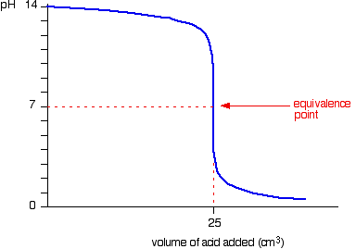sample solution. We would then add 2.00 mL of the acid and measure the resulting pH. We would continue to add successive amounts of acid and measure the pH at each step. When we plotted the resulting data, a **titration** or **pH curve** like the one to the right would result. You can see that the pH falls a small amount until quite near the equivalence point where there is a steep plunge. If you calculate the values, the pH falls all the way from 11.3 when you have added 24.9 cm3 to 2.7 when you have added 25.1 cm3. In other words, .1 cm3, which is the equivalent of 2 ½ drops, can make the difference between pH 7.0 and pH 11.3.

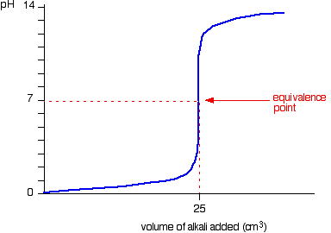If we were to titrate a strong acid with a strong base, the resulting titration curve would be very similar to the previous curve except, of course, that the pH starts off low and increases as you add more sodium hydroxide solution. Again, the pH doesn't change very much until you get close to the equivalence point. Then it surges upward very steeply.

# Practice problems

1. If it takes 16.5 mL of a 0.250 mol/L solution of hydrochloric acid to neutralize

100 mL of sodium hydroxide solution, what is the concentration of the base?

2. The hydrochloric acid in a solution of kettle-scale remover is titrated with a 0.974 mol/L solution of sodium hydroxide. 10.00 mL samples of the acid solution were used. The color change of bromothymol blue indicator to green indicates the endpoint.

**Trial 1 2 3 4**

**Final burette reading (mL)** 15.6 29.3 43.0 14.8

**Initial burette reading (mL)** 0.6 15.6 29.3 1.2

**Volume of NaOH added (mL)**

**Color at endpoint** blue green green green

# Assignment

1. When combining a strong base with a strong acid, which indicators would be suitable to indicate when the reaction is complete? Would the colour changes for the indicators indicate the exact equivalence point for the reaction? Explain.

2. What volume of 2.00 mol/L hydrochloric acid is needed to neutralize 1.20 g of dissolved sodium hydroxide?

3. 3.78 g of solid oxalic acid (HOOCCOOH · 2H2O (s)) is dissolved in some water to form a solution. If the acid neutralizes 125 mL of a lithium hydroxide solution, what is the concentration of the basic solution?

2 LiOH (aq) + HOOCCOOH (aq) → 2 HOH(l) + LiOOCCOOLi (aq)

4. What volume of 3.00 mol/L nitric acid is required to neutralize 60.0 mL of 0.10 mol/L sodium hydroxide solution?

5. What volume of 1.00 mol/L sulfuric acid is required to neutralize 60.0 mL of 0.35 mol/L rubidium hydroxide solution?

6. In order to neutralize 3.78 g of ethanoic acid, it was necessary to add 125 mL of a barium hydroxide solution. What was the concentration of the barium hydroxide solution?

7. If 1.86 mL of a 1.000 mol/L standard solution of sodium hydroxide is required to neutralize 5.00 mL of a hydrobromic acid solution, what is the concentration of the acid solution? What is the pH of the acid solution?

8. A student wanted to determine the hydrogen ion concentration of an unknown strong acid solution. 200 mL of the acid solution reacted with 3.27 g of zinc. Write the non-ionic, total ionic and net ionic equations for this reaction. What was the pH of the unknown acid solution?

9. What is an appropriate indicator for a titration with an equivalence point pH of 4.4?

10. The following data was recorded for the titration of 10.00 mL of 0.120 mol/L sodium carbonate solution with hydrochloric acid. The color change of methyl orange is used to indicate the endpoint. Calculate the concentration of the acid.

**Trial 1 2 3 4**

**Final burette reading (mL)** 17.9 35.0 22.9 40.1

**Initial burette reading (mL)** 0.3 17.9 5.9 22.9

**Volume of HCl(aq) added (mL)**

**Color at endpoint** red orange orange orange

11. Do problem 1 on page 332.

12. A 20.0 mL sample of hydrochloric acid was titrated with 0.10 mol/L sodium hydroxide. The following results were recorded.

|  |  |  |  |  |  |
| --- | --- | --- | --- | --- | --- |
| **VNaOH (mL)** | **pH** | **VNaOH (mL)** | **pH** | **VNaOH (mL)** | **pH** |
| 0.0  2.0  4.0  6.0  8.0  10.0  12.0  14.0  16.0  18.0  20.0 | 0.82  0.90  0.97  1.03  1.10  1.18  1.25  1.33  1.41  1.50  1.60 | 22.0  24.0  26.0 28.0  28.5  29.0  29.5  29.8  30.1  30.5  31.0 | 1.72  1.87  2.06  2.38  2.51  2.69  3.00  3.40  10.30  11.00  11.29 | 32.0  34.0  36.0  38.0  40.0  42.0  44.0  46.0  48.0 | 11.59  11.87  12.03  12.14  12.22  12.29  12.34  12.38  12.42 |

Using graph paper, draw the resulting pH curve and indicate the location of the equivalence point. Calculate the concentration of the acid.

13. Do problem 17 on page 348.